Dear Colleagues,

Now that we have come to the closure of Performance cycle 2022, we would like to ensure that any appeals get managed efficiently. As you saw in the communication, we have asked that any concerns get forwarded to the LM and HRBPs by latest this Friday. Kindly ensure that HRBPs are handling these concerns with priority, and that any changes to the current rating, get communicated to Heba by end of day Monday 13th March. Kindly send us a consolidated list of all changes and provide your sign off, in the event that there is an appeal from a Band K, this will be taken up to the acting GDHR for final approval.

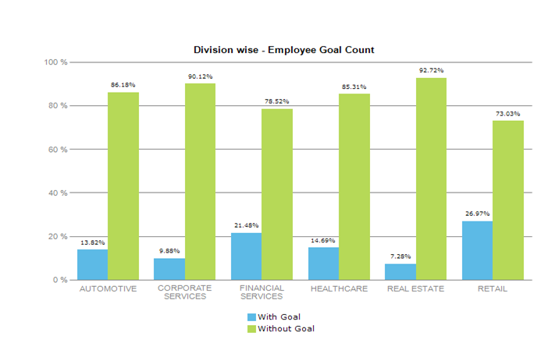
As you are aware, we got the approval on the Enable process late last year. With closure of Performance cycle 2022, and the system getting enabled to drive the process digitally, we are confident that this is the right time to roll out the process, and we will be taking a focused, staggered approach for the roll out.

What can you expect?
- We will start by educating your TM leads & HRBPs on the process. The plan is to start post 15th of March.
- Our first focus will go to employees who have rated 1 – Not Met, in their 2022 performance rating, and we encourage HRBPs to discuss which of the employees who were rated a 2- Partially Met, would benefit from being put on the process
- We will then run a round of education sessions for LM & HRBPs of this population cohort as a first focus, as we will require that these employees be put on Enable straight away. By having a focused group, it will provide us the opportunity to run a deeper conversation where concerns and questions get addressed fully.
- We will monitor the “Enable” process once initiated, and conduct regular checks with the leads to ensure the right support is available.
- We will provide you with a quarterly status report on the progress of employees enrolled in “Enable” program.
- Following this round of roll-out we will drive additional sessions for the wider line manager population base.

What actions are needed from the Division/Function?
- Sharing the information with your Leadership team in terms of the process and roll out approach.
- We will have a discussion with your TM leads to understand who will be part of this cohort ie. Confirming your Not Met population, aligning who from the Partially Met group should be included and understanding who is already part of an ongoing PIP process

You can now access the Enable Toolkit - 2023.

Please feel free to reach out to us for any clarification/support required.

Regards.

Gabriella Planojevic
Group Head of Talent Management
Al Futtaim Group | Corporate – HR Function
* gabriella.planojevic@alfuttaim.com
È +971 507094638

